DB Mgt SQL HW 1
Spring, 2014 due Mon, 31-Mar @ 4 pm

General notes
- Include your initials in the database filename.
- You are to create each query by typing the query statement. You are not to use the “drag and drop method” to create any query.
- Save each query ensuring you include your initials in each query name.
- Submit each database to its Bb task.

Part I. Use the Vacation db to complete these tasks.

1. Show in this order: PropertyName, Location, Country, PropertyType which sleep more than 4, Exclude castles & villas
Sort the data in alpha order by Country

Hint: PropertyType <> ‘Castle’ and PropertyTyp<> ‘Villa’ is easier done as
PropertyType Not In (‘Castle’,’Villa’)

2. Find Properties that sleep more than 6 and show who has reserved.
“Show” Guestname, start/end date, location, country, property name, sleeps
Revise: Let user select different #sleep

3. Find reservations for two countries (France & Italy)
Display Guestname, start/end date, location, country, property name, sleeps

Part II. Download the Shoots zip folder from Bb. In it you should find a PDF doc of the ERD for the Shoots database, a doc showing the structure of 4 tables in the db and the Shoot db. You should familiarize yourself with these before writing the queries specified below.

I can provide help, but see what you can do on your own. You may use the book.

1. Print a list of shoots sorted by date and then location. Display the shoot#, contract#, shoot type, shoot date, and location.

2. Create a parameter query to select clients based on city.
Display client#, client name, address, city, and phone; sort on client name

3. What clients have contracts over $700?
Give the client name, contract number, date of shoot, location and contract amt
Display in descending order of contract amount

4. What clients have requested services for sporting events?
Display client name, contract number, event description (not the code), and date of shoot

5. What are the “business” related events that have contracts? You will need to review the Event options in the ShootDesc table. Hint 1: Use the “in” qualifier in the Where clause instead a string of “or” statements
Display client#, client name, contract#, shoot date, and event description

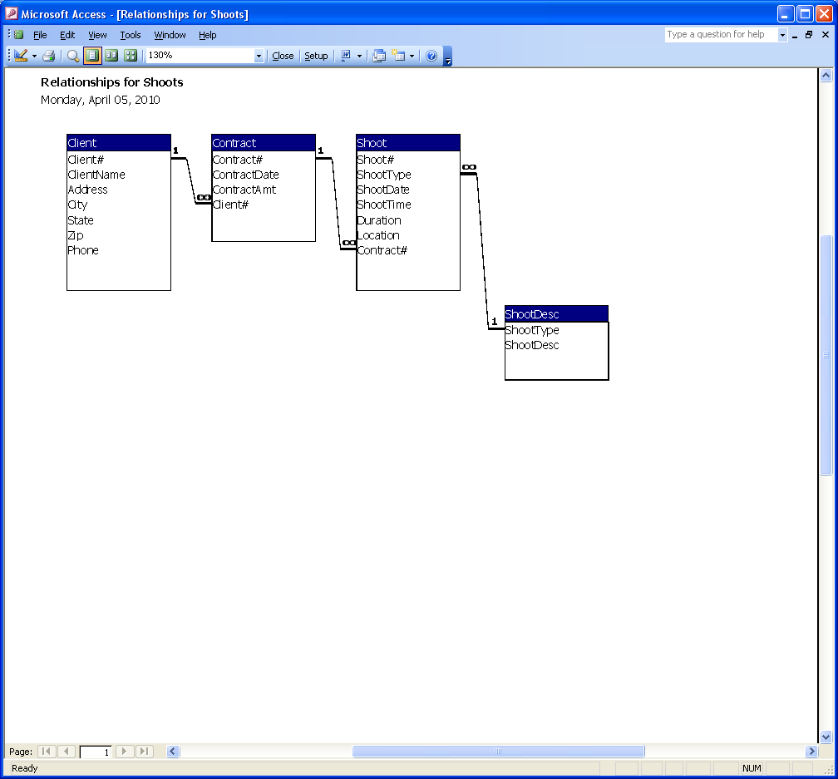
  ShootDesc
  ShootType | ShootDesc
  AC | Awards Ceremony
  AP | Anniversary Party
  BM | Bar/Bat Mitzvah
  BP | Birthday Party
  CO | Commercial
  CP | Insurance Commercial Property
  DR | Dance Recital
  GR | Graduation
  HP | Insurance Home Property
  LS | Legal Services
  RC | Religious Ceremony
  SE | Sports Event
  WE | Wedding

Table: Client Page: 1
Columns
Name Type Size
Client# Integer 2
ClientName Text 40
Address Text 32
City Text 24
State Text 2
Zip Text 10
Phone Text 14

Table: Contract Page: 2
Columns
Name Type Size
Contract# Integer 2
ContractDate Date/Time 8
ContractAmt Currency 8
Client# Integer 2

Table: Shoot Page: 3
Columns
Name Type Size
Shoot# Long Integer 4
ShootType Text 2
ShootDate Date/Time 8
ShootTime Date/Time 8
Duration Single 4
Location Text 30
Contract# Integer 2

Table: ShootDesc Page: 4
Columns
Name Type Size
ShootType Text 2
ShootDesc Text 30

